Square Antiprism
# Source: AI Source: Provided by: [Data Path: Persons Table -> ID Column: 1, Name_En Column: Motasem Essam] -> From: [ChatGPT] on [7/25/2026]
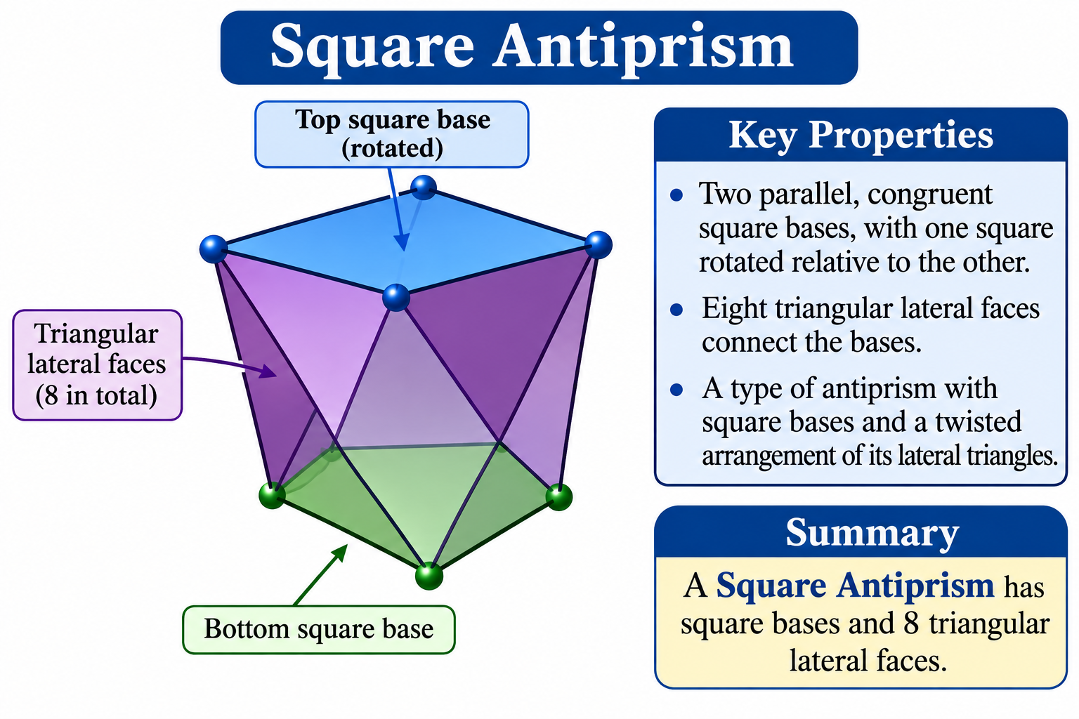

Definition
# Source: AI Source: Provided by: [Data Path: Persons Table -> ID Column: 1, Name_En Column: Motasem Essam] -> From: [ChatGPT] on [7/25/2026]
A Square Antiprism is a polyhedron consisting of two parallel, congruent square bases, with one square rotated relative to the other. The bases are connected by eight triangular lateral faces.
It is a type of antiprism with square bases and a twisted arrangement of its lateral triangles.
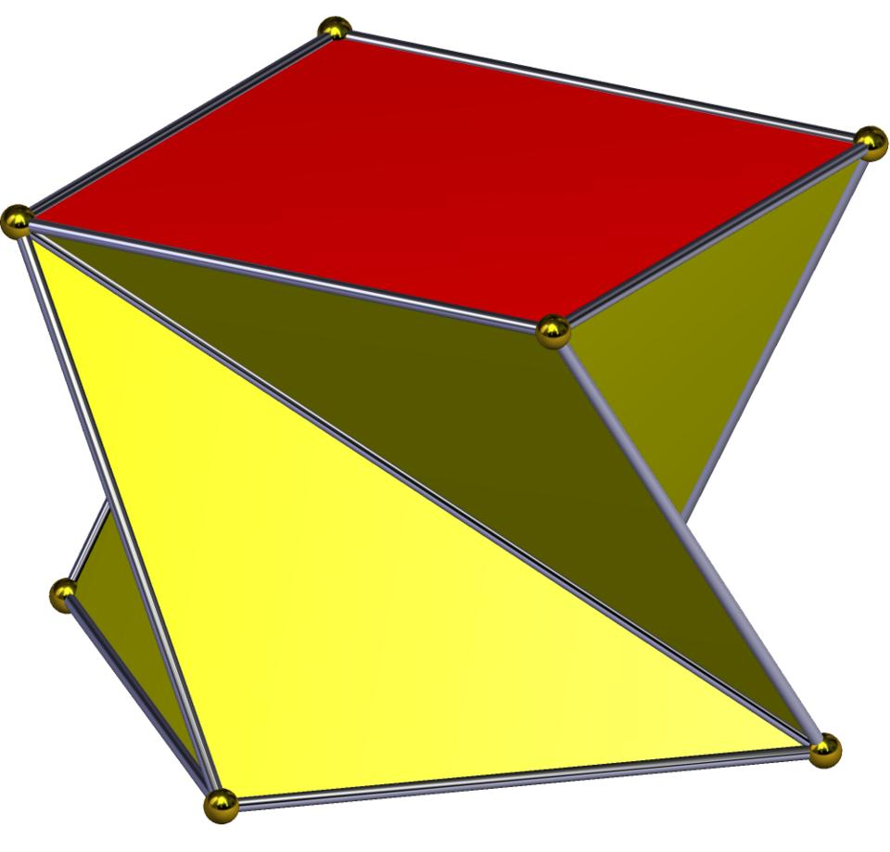

Geometric Structure
# Source: AI Source: Provided by: [Data Path: Persons Table -> ID Column: 1, Name_En Column: Motasem Essam] -> From: [ChatGPT] on [7/25/2026]
The square antiprism consists of:
- Upper Square Base: A square forming the top face.
- Lower Square Base: A congruent square forming the bottom face, rotated relative to the upper base.
- Triangular Lateral Faces: Eight triangles connecting the corresponding vertices of the two square bases.
- Vertices: Eight vertices, with four on each base.
- Edges: Sixteen edges connecting the vertices.

Face Composition
# Source: AI Source: Provided by: [Data Path: Persons Table -> ID Column: 1, Name_En Column: Motasem Essam] -> From: [ChatGPT] on [7/25/2026]
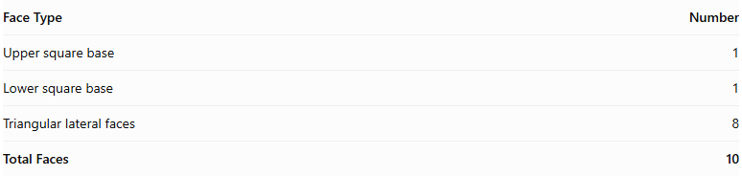
Face Type | Number
Upper square base | 1
Lower square base | 1
Triangular lateral faces | 8
Total Faces | 10

Mathematical Properties
# Source: AI Source: Provided by: [Data Path: Persons Table -> ID Column: 1, Name_En Column: Motasem Essam] -> From: [ChatGPT] on [7/25/2026]
For a square antiprism:
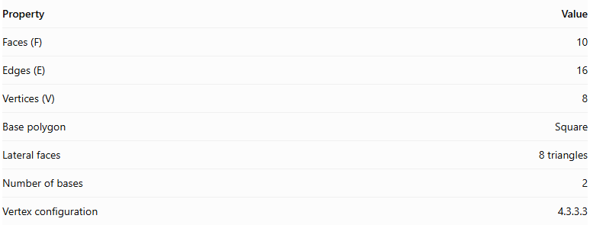
Property | Value
Faces (F) | 10
Edges (E) | 16
Vertices (V) | 8
Base polygon | Square
Lateral faces | 8 triangles
Number of bases | 2
Vertex configuration | 4.3.3.3
Euler's formula:
$$V-E+F=2$$
$$8-16+10=2$$
Regular Square Antiprism
In a regular square antiprism:
- Both square bases are regular and congruent.
- The upper and lower bases are rotated relative to each other, typically by ${45}^{∘}$.
- The eight lateral triangular faces are equilateral.
- All vertices have the same local arrangement.

Constructing Square Antiprism in Solid Geometry

Geometric Instruments Used
# Source: AI Source: Provided by: [Data Path: Persons Table -> ID Column: 1, Name_En Column: Motasem Essam] -> From: [ChatGPT] on [7/25/2026]
The construction uses traditional geometric instruments rather than coordinate-based construction.
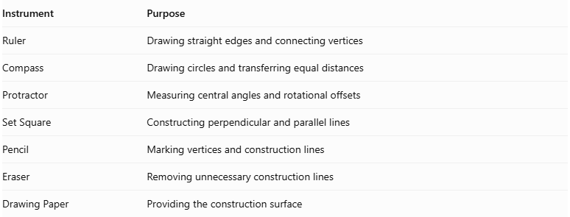
Instrument | Purpose
Ruler | Drawing straight edges and connecting vertices
Compass | Drawing circles and transferring equal distances
Protractor | Measuring central angles and rotational offsets
Set Square | Constructing perpendicular and parallel lines
Pencil | Marking vertices and construction lines
Eraser | Removing unnecessary construction lines
Drawing Paper | Providing the construction surface

Instrument-Based Construction Procedures

Constructing the Lower Square Base
# Source: AI Source: Provided by: [Data Path: Persons Table -> ID Column: 1, Name_En Column: Motasem Essam] -> From: [ChatGPT] on [7/25/2026]
- Draw a circle using a compass.
- Mark its center.
- Divide the circumference into four equal angular sections using a protractor.
- Each central angle measures:
$$\frac{{360}^{∘}}{4}={90}^{∘}$$
- Mark the four points around the circumference.
- Connect consecutive points using a ruler.
- Complete the regular square base.

Constructing the Upper Square Base
# Source: AI Source: Provided by: [Data Path: Persons Table -> ID Column: 1, Name_En Column: Motasem Essam] -> From: [ChatGPT] on [7/25/2026]
- Draw a second congruent square above the lower base.
- Keep the two base planes parallel.
- Rotate the upper square by ${45}^{∘}$ relative to the lower square.
- Ensure that both square bases have equal side lengths.
- Maintain the required perpendicular separation between the two base planes.

Connecting the Two Bases
# Source: AI Source: Provided by: [Data Path: Persons Table -> ID Column: 1, Name_En Column: Motasem Essam] -> From: [ChatGPT] on [7/25/2026]
- Connect each upper-base vertex to the two neighboring lower-base vertices.
- Repeat the alternating connections for the remaining upper-base vertices.
- Connect each lower-base vertex to its two neighboring upper-base vertices.
- Form eight triangular lateral faces.
- Check that the triangular faces form a continuous band around the solid.

Completing the Antiprism
# Source: AI Source: Provided by: [Data Path: Persons Table -> ID Column: 1, Name_En Column: Motasem Essam] -> From: [ChatGPT] on [7/25/2026]
- Verify that both square bases are congruent and parallel.
- Check the ${45}^{∘}$ rotational offset.
- Darken the visible external edges.
- Represent hidden edges using dashed lines when necessary.
- Remove unnecessary construction marks.
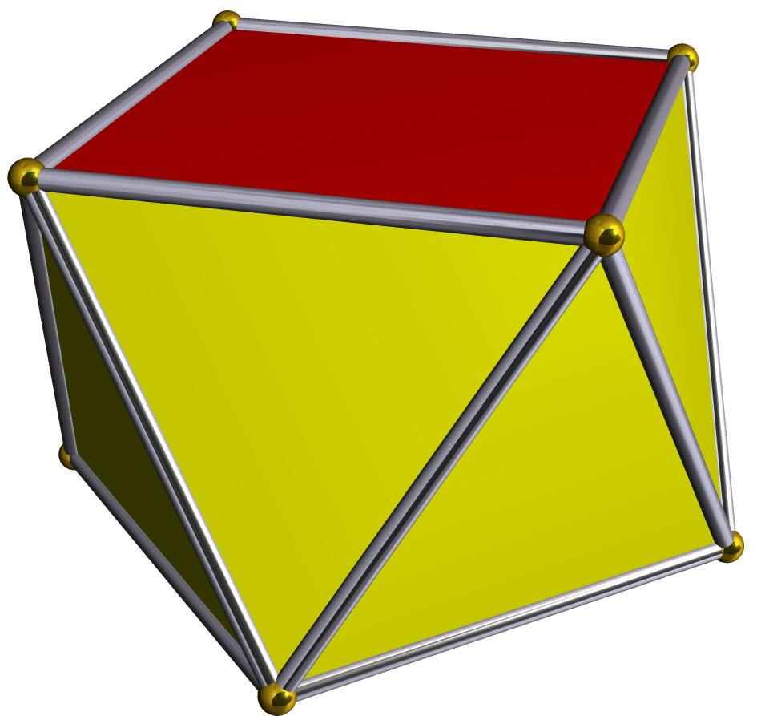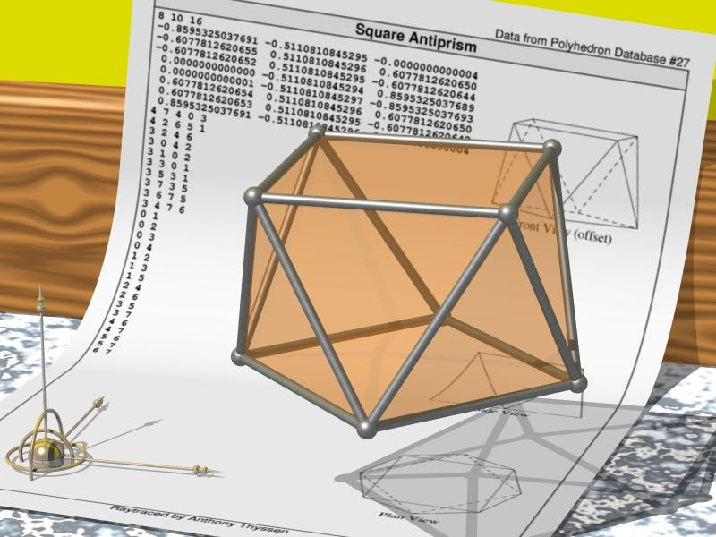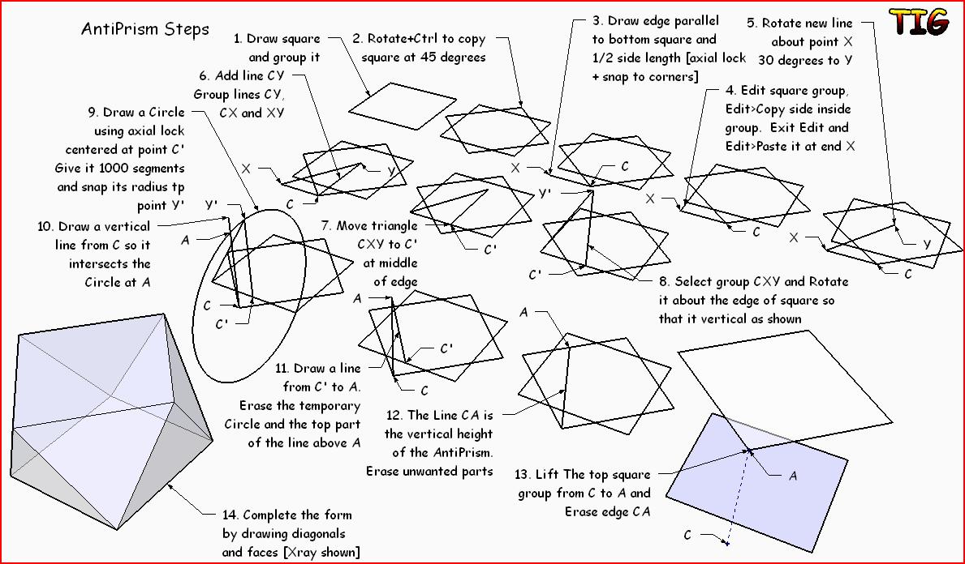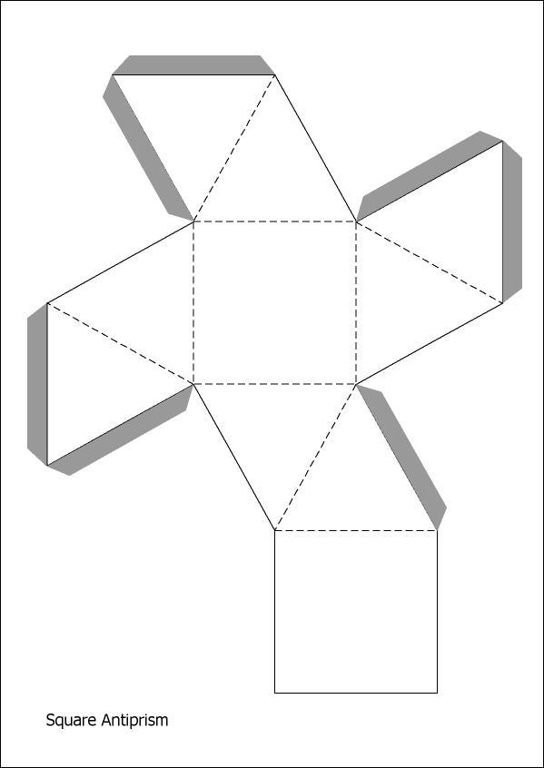

Key Points
# Source: AI Source: Provided by: [Data Path: Persons Table -> ID Column: 1, Name_En Column: Motasem Essam] -> From: [ChatGPT] on [7/25/2026]
- It has two parallel square bases.
- The bases are rotated relative to each other.
- It has eight triangular lateral faces.
- It contains 10 faces, 16 edges, and 8 vertices.
- Its regular form is a uniform polyhedron.

Conclusion
# Source: AI Source: Provided by: [Data Path: Persons Table -> ID Column: 1, Name_En Column: Motasem Essam] -> From: [ChatGPT] on [7/25/2026]
A Square Antiprism is an antiprism with two congruent square bases and eight triangular lateral faces, arranged in a twisted configuration.

